1. Helpful documents

<https://docs.unity3d.com/Packages/com.unity.xr.openxr@1.3/manual/index.html>

<https://docs.unity3d.com/Packages/com.unity.xr.interaction.toolkit@2.0/manual/index.html>

<https://docs.unity3d.com/Packages/com.unity.inputsystem@1.3/manual/index.html>

1. Files where you should start looking at:
2. Main Scene:

Assets/Scenes/Prototype/PrototypeScene.unity

1. The Vacuum Gun Prefab:

Assets/Prefabs/Weapon/VacuumGun.prefab

3. Code structure:

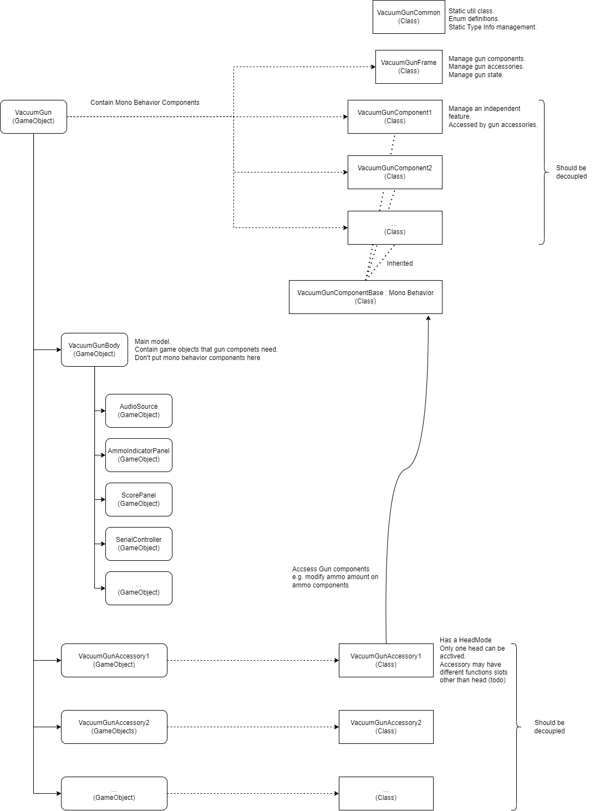

4. Folder structure

Assets

├─ArtAssets // Audio, Meshes, Material, External Scene, Animations. Need cleanup.

├─Data // Scriptable Objects storing game data

│ └─Presets

│ └─XR Interaction Toolkit

│ └─2.0.0-pre.6

│ └─Default Input Actions

├─Plugins // Normally don’t touch these unless you know how to do with a specific plugin

│ ├─Ardity

│ ├─TextMesh Pro

│ ├─XR

│ └─XRI

├─Prefabs

│ ├─EnemyTarget

│ ├─Environment

│ ├─Interactable

│ │ └─Screws

│ **└─Weapon // VacuumGun.prefab here**

├─Scenes

│ └─Prototype

│ └─PrototypeScene

├─Scripts

│ ├─Collectable

│ ├─EnemyTarget

│ ├─Utilities

│ └─VacuumGun

└─StreamingAssets

5. Project settings

Tags:

Tag 0 Projectile: used for bullet projectile colliders

Tag 1 Collectable: used for collectable object (e.g. screws) colliders

Tag 2 Floor: used for the floor collider